TrustCore Dashboard Guide
Last updated 22 October 2026. This one's for people actually using the dashboard day to day, admins, employees, and customers alike. If you're after the code underneath it, that's a separate document (the Developer Guide).

Accounts and roles
Every login in TrustCore is tied to one of three roles, and the role decides what you can touch:
Role | Who it's for | What they manage
Admin | Whoever runs the system day to day | Everything: offers, products and templates, insurance companies, every customer and staff account, site-wide settings, and the raw Collections editor underneath it all
Employee | Operational staff, advisors, case handlers | Offers, customers, products and templates, insurance company credentials, their own dashboard settings
Customer | The people the offers are actually for | Their own offers, plus their personal dashboard settings
A quick way to think about it: Admin can see and change almost anything, Employee runs the day to day business without touching staff accounts or the underlying content model, and Customer sees only what belongs to them. If a menu item mentioned below isn't showing up for you, that's your role working as intended, not a bug.

Signing in
Head to /auth/login, type in your email and password, and click Log In. A successful login drops you straight on the Dashboard.
Forgot your password? There's a "Forgot Password" link right there on the login screen. Enter the email on file and the reset flow takes it from there.
If login keeps failing and you're sure the password's right, the problem is usually on the account side, not yours: either the account hasn't been created yet, or nobody's assigned it a role. That's an admin fix, not something you can sort out from the login screen.

Finding your way around
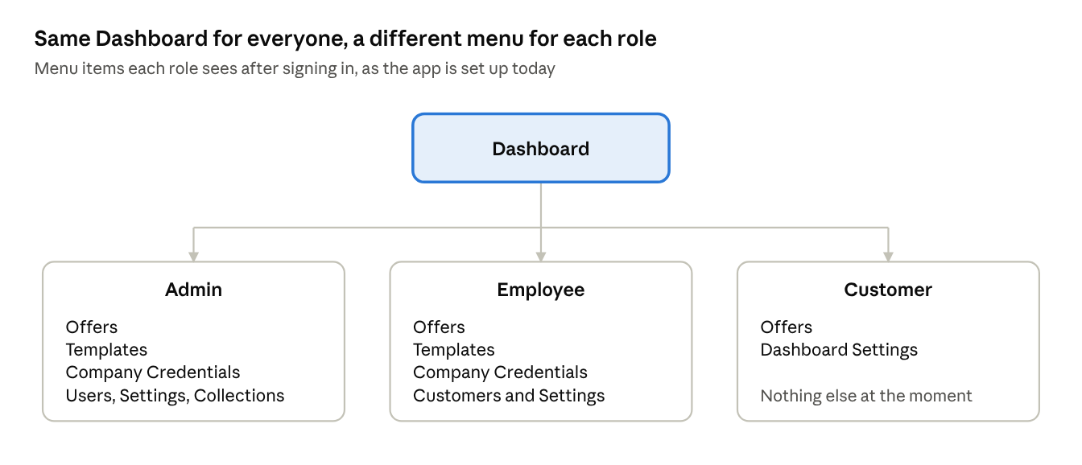
Menus by role · Admin, Employee, Customer
Dashboard sits at the top of the menu for everyone. Below that, what you see depends entirely on your role (above). Here's the full list of what exists, even if your account doesn't show all of it:
- Dashboard, an overview of what's going on.
- Offers, where quotes and comparisons for customers live.
- Templates, the field layouts behind offers and products (admin and employee only).
- Company Credentials, insurance company records and their access details (admin and employee only).
- Customers, profile data for the people offers are built for (mostly an employee screen, admins work through Users instead).
- Users, staff and admin accounts, including role assignment (admin only).
- Dashboard Settings, your own language and theme preferences.
- Collections, the raw content model everything else is built on top of (admin only, and genuinely an advanced screen, see below).
Pick a language other than English in your Dashboard Settings and the menu itself switches over. Anything without a translation yet just falls back to English.

Offers
An offer ties one customer to one insurance comparison, with a generated PDF attached at the end.
Creating one. Go to Offers → Create Offer. Give the offer a title, pick the customer it's for from the dropdown, and choose the template, which is the insurer and product set you're quoting (Groupe Mutuel and Nur KVG are the ones used most so far). The template then brings up its own fields: start dates, insurance models, coverage levels, deductibles and so on. Fill those in and click submit, then confirm when the dashboard asks whether you want to go ahead and create the offer. You don't set a status or upload a PDF yourself. Both are handled for you, as described below.
Finding and editing one. Offers → List Offers gives you the full table, searchable and filterable. Click the edit icon on a row to open it up, or the trash icon to remove it (you'll get a confirmation prompt first, nothing deletes on a single click).
One thing worth knowing: if you're not an admin, anything you create gets quietly tagged as yours behind the scenes. Depending on how the account's been set up, that can mean you only ever see offers you personally created, not the whole list. If that doesn't match what you expected, that's a question for an admin, not a bug report.

After you submit
The offer is saved straight away and you'll see "Offer has been created. You'll receive an email with offer PDF". The PDF itself isn't made on the spot. A separate automated process, built in Microsoft Power Automate, picks the offer up, prepares the offer document, and sends it back to TrustCore. You can follow it in the Status column under Offers → List Offers:
Status | What it means | What to do
Creating Offer | The offer has been handed over and the PDF is being prepared | Nothing yet, just give it time
Ready | The PDF is attached and the email has gone out | Open the offer to view or download the PDF
Failed | The automation couldn't produce the PDF | Check the offer's details (customer data, template choices), then create it again or ask an admin to look
If an offer stays at Creating Offer much longer than your other offers took, it has probably got stuck. It won't sort itself out, so let an admin know the offer's title and they can check the automation.

Templates and the field builder
A template is what decides which fields show up when someone creates or edits a record, whether that's an offer, a customer profile, or one specific insurer's health-insurance product. Think of it as the form layout, defined once and reused everywhere that product type appears.
Most of the heavy lifting here is already done. Every insurer and product line already sitting in the system (health, accident, liability, legal protection, and so on) has its own template with its own set of fields, coverage tiers, and deductibles. You'll rarely need to build one from scratch.
When you do:
- Templates → Create Template, give it a name, save.
- Open its Blueprint (the field builder) and start adding fields. Each one needs a name, a type (plain text, a date, a file or image upload, a dropdown linking to another record, or a simple yes/no toggle), and whether it's required.
- The moment a field exists on a template, every record using that template picks it up automatically. Nobody has to touch any code for that to happen.
Templates → List Templates shows everything that's already been built.

Collections, for admins only
Collections is the engine underneath Offers, Templates, and most of the rest of the app. A collection is just a named content type: Offers is one, Health Insurance is one, each specific insurer's product line is its own collection too. There are dozens already set up, and most people will never open this screen directly, since Offers, Templates, Company Credentials and Customers are really just friendly front doors onto specific collections.
If you're an admin and genuinely need to work at this level:
- Collections (the list view) shows every collection, its status, and lets you create, rename, or delete one.
- Each collection's entries are its actual records. One offer is one entry in the Offers collection, and so on. You can view, create, edit and delete entries straight from a collection's table.
- The fields on a collection come from whatever template it's attached to (see above). To change what fields show up, edit the template's blueprint, not the collection.
Be careful in here. Deleting a collection, or removing a field that's already in use, can take existing offers or customer records down with it. When in doubt, check with whoever handles the technical side before deleting anything.

Customers and staff users
Customers, visible to employees and admins, holds the profile data behind every offer: contact details, address, date of birth, gender, current insurer, nationality, residence permit, and the handful of other fields the insurance forms actually ask for. List, search, create, edit, and delete from here, and the table has export buttons for PDF and Excel when you need the data outside the system.
Users, admin only, is the equivalent screen for staff and admin accounts, with one extra piece: you assign the role (admin, employee, or customer) right there when you create or edit someone's account.

Your dashboard settings
Dashboard Settings is personal to your own login: switch your language, pick a theme, that's it. Admins additionally have a separate site-wide settings screen (company name, logo, contact email) that changes what everyone sees across the whole app, so that one's worth a second look before saving.

Exporting data
Wherever you see export buttons on a table (Customers and Users are the main ones), you can pull the current view down as a PDF or an Excel file. Handy for anything that needs to leave the system: a report for a meeting, a backup before a big cleanup, whatever the occasion.

When something's not working
What's happening | What it usually is
Can't log in | Double-check the email and password first, then try Forgot Password. Still stuck? Ask an admin to confirm the account exists and has a role on it.
A menu item I expect isn't there | That's your role, not a glitch. Ask an admin if you think you should have access.
I created something but can't find it later | If you're not an admin, you may only see records tied to your own account. Worth asking an admin to check.
Page looks broken or blank after an update | Hard refresh first. Still broken? That's one for development to look at, not something to fix by clicking around.

A few terms, in case they come up
- Collection. A configurable content type: Offers, a specific insurer's product, and so on.
- Template / Blueprint. The field definition attached to a collection. It decides what the create and edit forms actually ask for.
- Entry. One actual record inside a collection, one specific offer, for example.
- Offer. A customer-facing insurance comparison with a PDF attached.
- Role. Admin, Employee, or Customer, and the thing that decides what you see.

